**Student: Byeongnam Kang, Jaehun Lee**

**Student ID:2017314649, 2017314626**

**Course Section Number: SWE3048_43**

**WEB PROJECT**

**REPORT**

**[GAME VIEW]**

# Main pages for not logged-in user

## [Home Page (Theme 1)]

## [Home Page (Theme 2)]

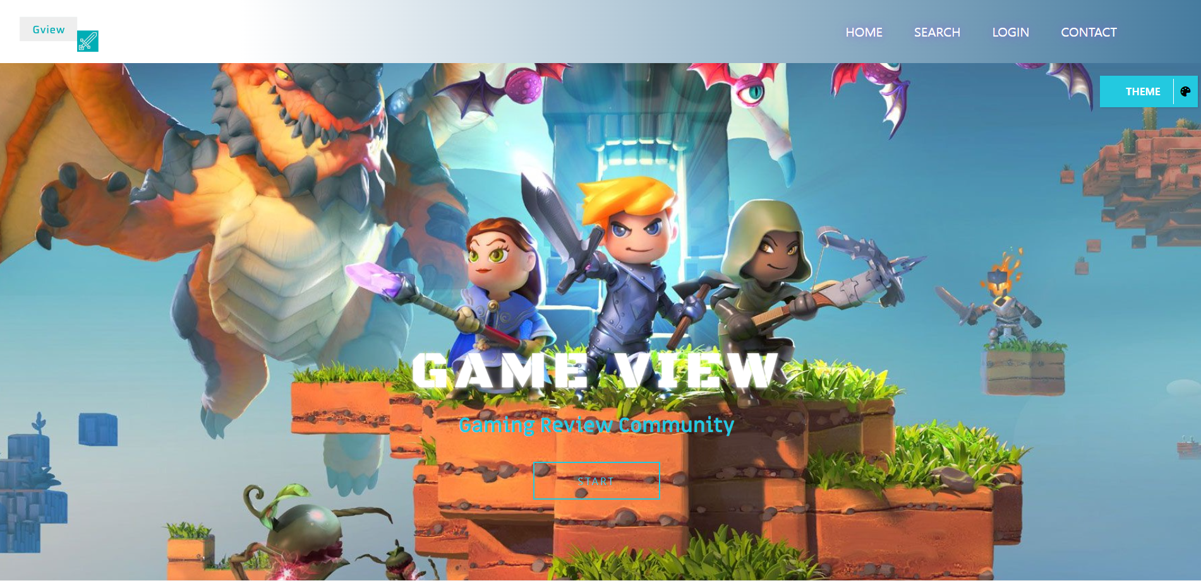

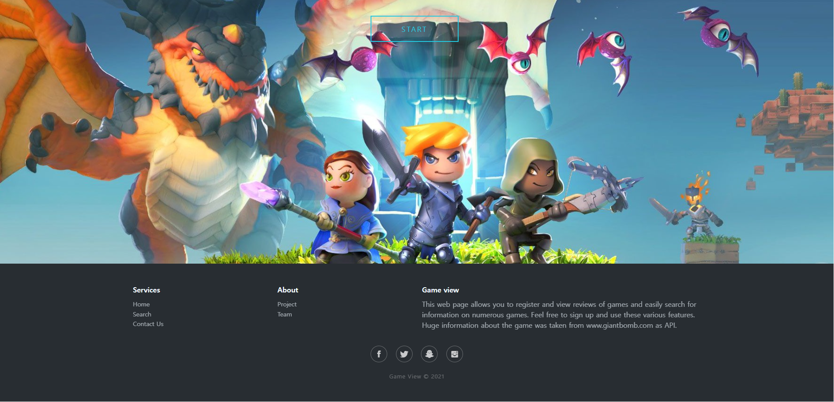

## [Home Page (Theme 3)]



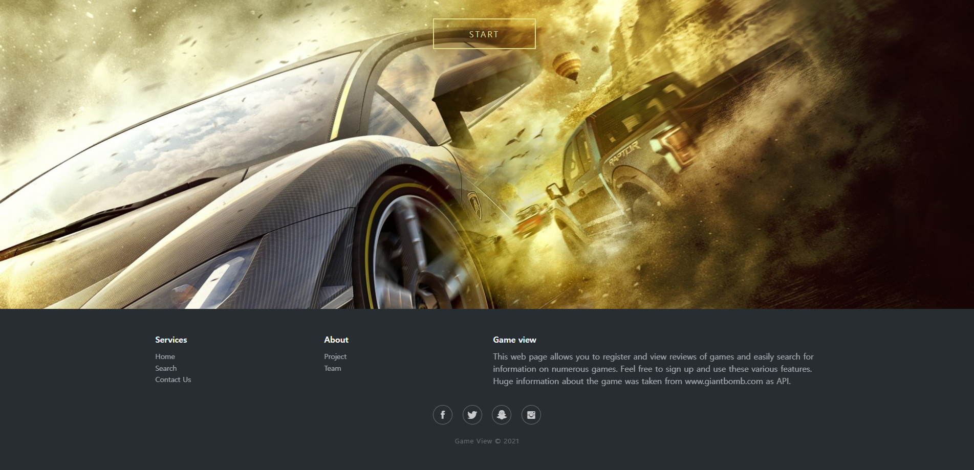

[Main Function]

* Select Home button on header: Change the display to home page.
* Select Search button on header: Change the display to search page. In search page we can search game and select game.
* Select Login button on header: Change the page to login page. In login page we can create an account or login to our website.
* Select Contact button on header: Change the display to contact us page. In contact us page we can send message to our email or service center(this is not included because it is not actually real company) and also we can see the information of our work
* Select Start button: Change the display to search page. This button is for better UI.
* Select Theme button on side: W can change and save theme of this website. Save what theme you chose to local storage and maintain the theme through that information when you reconnect to the web page.

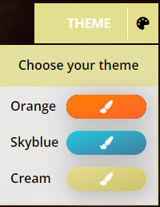Theme 1: Main color is orange and sub color is black

Theme 2: Main color is skyblue and sub color is white

Theme 3: Main color is cream and sub color is white

This theme function changes not only the overall color but also wallpaper and the color of the logo.

* Select Home button on footer: Same work as the Home button on header
* Select Search button on footer: Same work as the Search button on header
* Select Contact us button on footer: Same work as the Contact button on header
* Select Project button on footer: We can see information about our class and project by modal

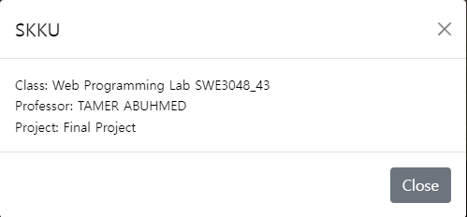

* Select Team button on footer: We can see information about our team by modal

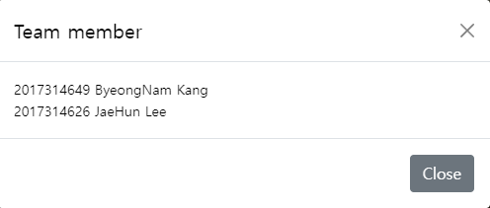

* Select Social Network button on footer: We can go to social network account of our website(this is also not exist because it is not actually real working website).



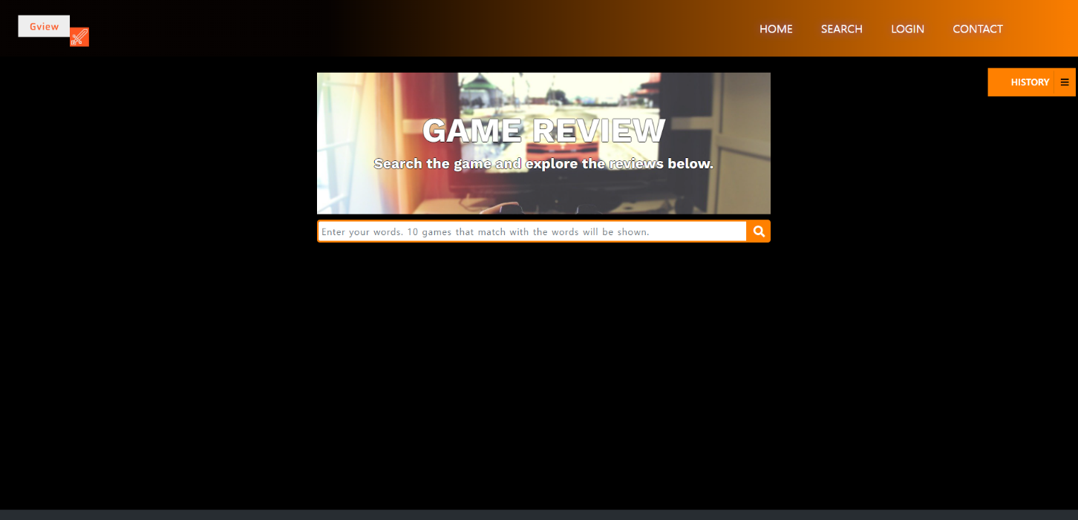**[Search Page]**

This page changes color by theme color.

[Main Function]

* Enter the name of the game you want to find and press the magnifying glass button: Render the game json(giantbomb.com) related by input form.
* Check blank: If there is no input message “No games found!” will show.
* 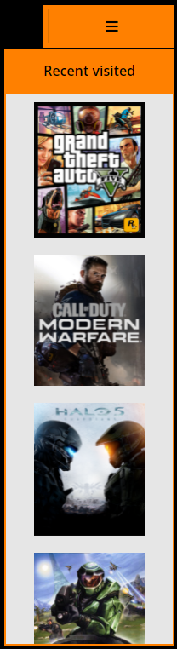Select History button on side: We can see recent visited game in this modal. We can access game by clicking game image. It’s maximum number is 5 and game that already in the recent visited do not added to modal again and, not exist in modal and also most recent visited game will added to top. A list of recently visited games is stored in local storage, and even if you reconnect to the website, the recent visit record still remains.

**[Search Page (Game searched)]**

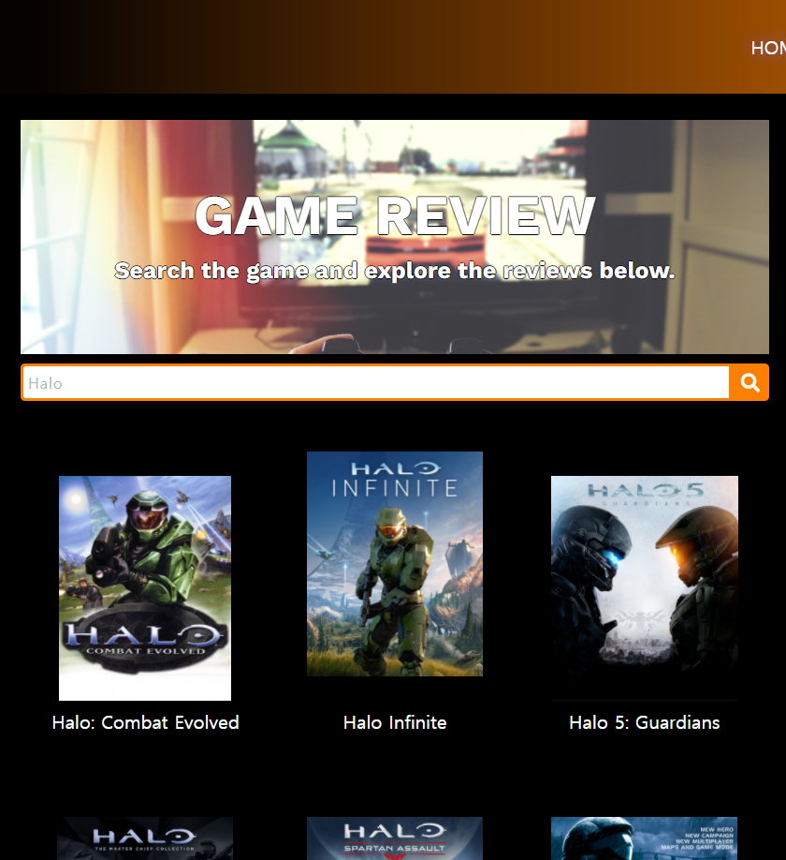

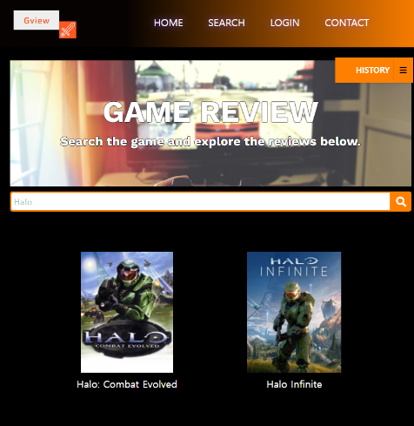

Games are rendered. Maximum number of game searched is 10. And basic row Grid number is 3 but window became small, row number is 2.

[Main Function]

* Select specific game image: Go to the page where you can view the information and reviews of the selected game.

**[Contact us Page]**

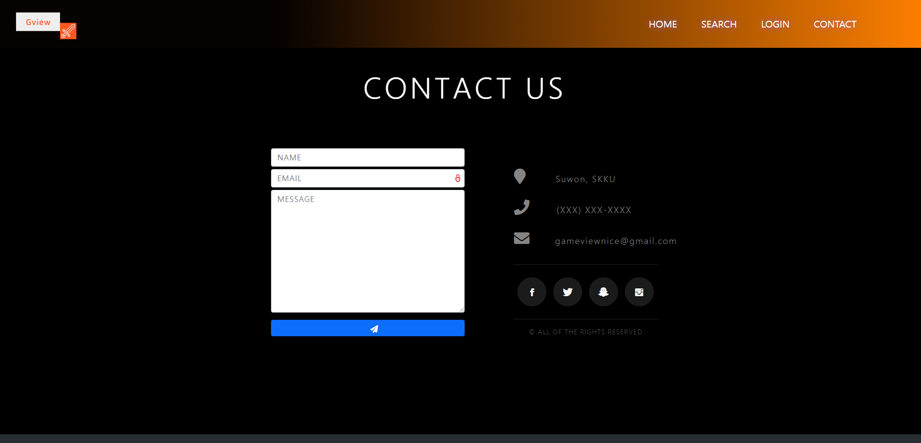

[Main Function]

* Send message form: We can send message to client service email(This is not exist because it is not actually real working website) by filling this form.
* Select Social Network button: We can go to social network account of our website(this is also not exist because it is not actually real working website).
* Select phone number: We can call to specified phone number by excuting your own program.
* Select email: We call directly email to specified email by clicking email. It will automatically excute your computer program.

# Create an account & log in

## [Login Page]

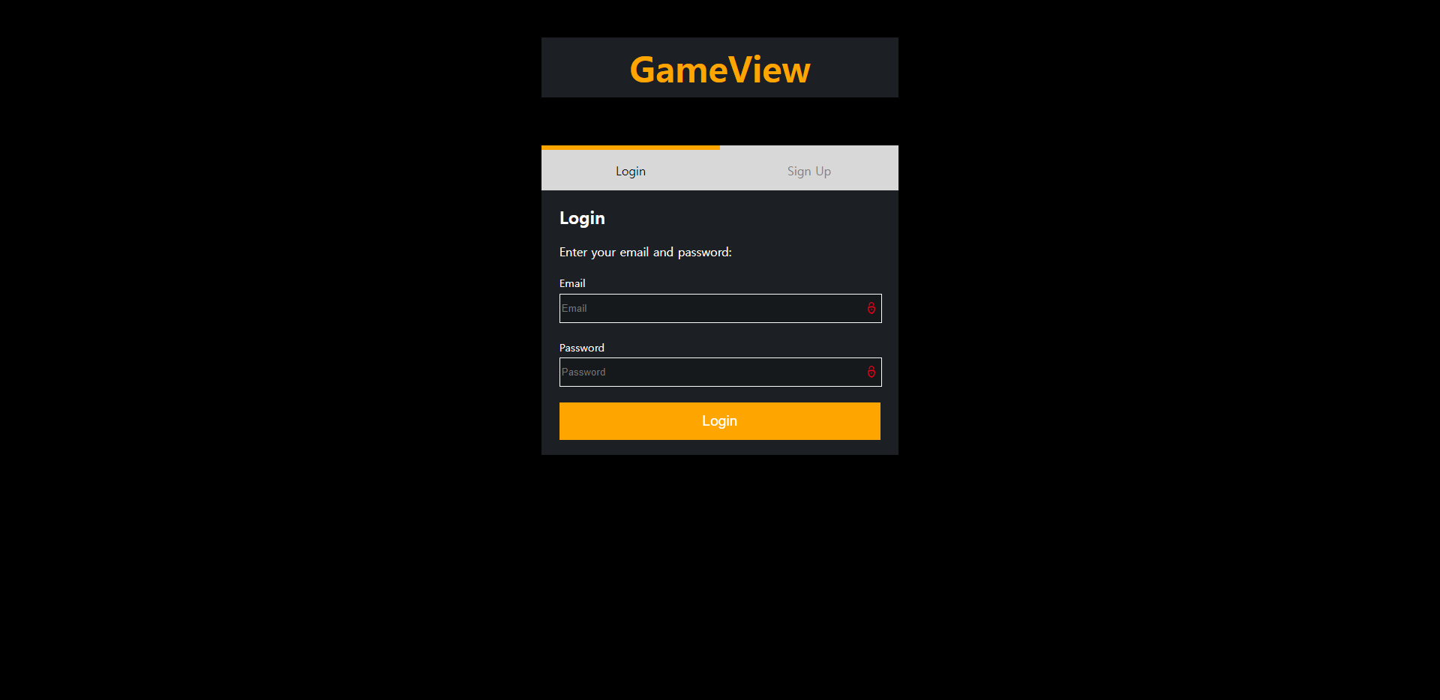

[Main Function]

* Check no blank form when login clicked: If the user doesn’t fill all form and click the login button, it happens login fail alert. So, we should fill all forms.
* Check id and password: If id and password information does not match in the database, it will alert message.
* Select sign up button: We clicks the “Sign Up” button, the user can move to the sign up page.
* Success Login: If we success in login, the user can move to the home page.

## [Sign Up Page]

[Main Function]

* Check Nickname duplicate: When sign up button clicked checks whether the nickname is already in the database.
* Check Email duplicate: When sign up button clicked checks whether the email is already in the database.
* Check password and confirm password: We will check the password and confirm the password is the same.
* Check no blank form when register clicked: If the user doesn’t fill all form and click the Sign up button, it happens sign up fail alert. So, we should fill all forms.
* Create an account: If the user success creates account, user can log in and enjoy our website contents.
* Select Login button: We clicks the “Login” button, the user can move to the sign up page.

# Main pages for logged-in user

## [Home Page]

This is the home page for logged-in user. Overall, it is similar to the version that is not logged in, but there is a difference.

[Main Function]

* 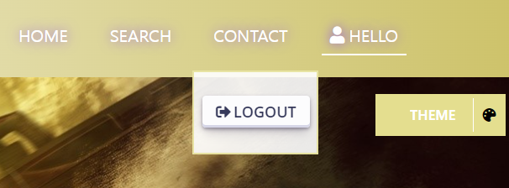Select User nickname button: There was a login button on a page that was not logged in, but the logged in page is replaced by the user's nickname. When you click the user's nickname, a button for logging out appears.
* Select Log out button: We can log out by click “Logout” button. It will take you to not logged-in main page.

# Game pages for not logged-in user

## [Game Page]

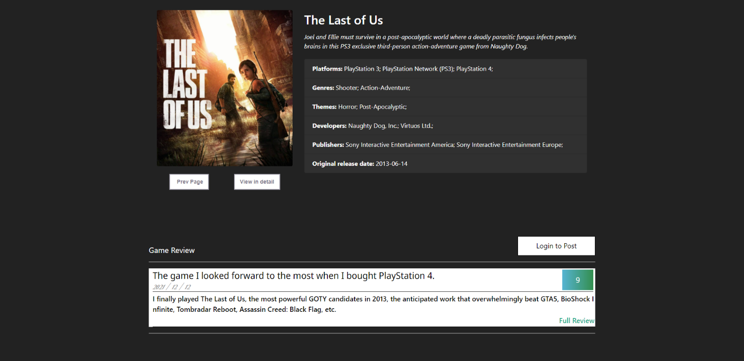On this page, we can see information about the game (platform, genre, theme, developer, publisher, release date) and see reviews written by users.

[Main Function]

* Select Prev Page button: Go to the previous page by click “Prev Page” button.
* Select View in detail: You can go to the “giant bomb” website to get more detailed game information and news.
* Select Login to Post button: You can see reviews on the game page that you are not logged in, but you cannot post reviews. Therefore, pressing the "Login to Post" button moves to the login screen.
* Posted Review: The simplified review shows the review title, post date, review summary, and score. It is the data received from our database.
* Select Full Review button: When clicked, a page showing a detailed review of the selected review card appears in a new window.

## [Game page]

[Main Function]

* Data received from the database: Render review data received from the database to a new window.
* Changes in sentences below the score: It depends on the score. Ten to eight points are green, "Strongly recommended! God game!" Seven to six points are orange, "Maybe you can enjoy it. Try it." Five to four points are black, and below that is red. "Do not play this. It's literal game.".
* Image change: Pepe's expression changes to four stages depending on the score. He looks happy at high scores, but sad at low scores.

# Game pages for logged-in user

## [Game page]

[Main Function]

* Select Post Review button: Now that we're logged in, we can post reviews. When you click the "Post Review" button, a modal for registering reviews appears.

## [Post Review page]

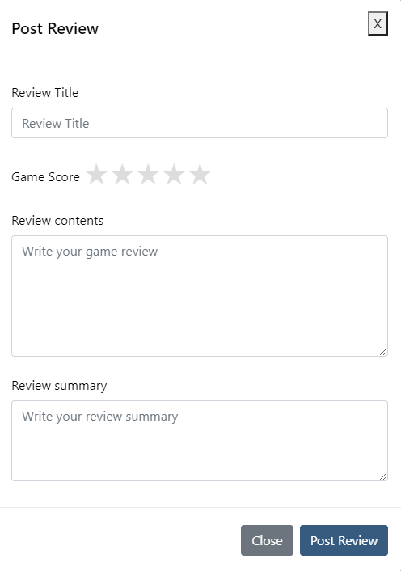

* Check no blank form when Post Review clicked: If the user doesn’t fill all form and click the “Post Review” button, it happens post fail alert. So, the user should fill all forms.
* Select game score star: Click on the stars to decide how many stars to choose. It is 1 point per half-space of a star.
* Select Post Review button: If the review post is successful, the review is stored in our database. After that, the review post window is turned off and rendered to the review on the game page.

# Database with MySQL

## [gamedb table(games)]

## [gamedb table(user)]

user: root

password : 7702